Andrew Rutherford

CSCI 3104

CPU: 2.8 GHz Intel Core i7

Ram: 16 GB 1600 MHz DDR3

OSX Yosemite

Homework #3



On my honor, as a University of Colorado at Boulder student, I have neither given nor received any unauthorized help.

1. 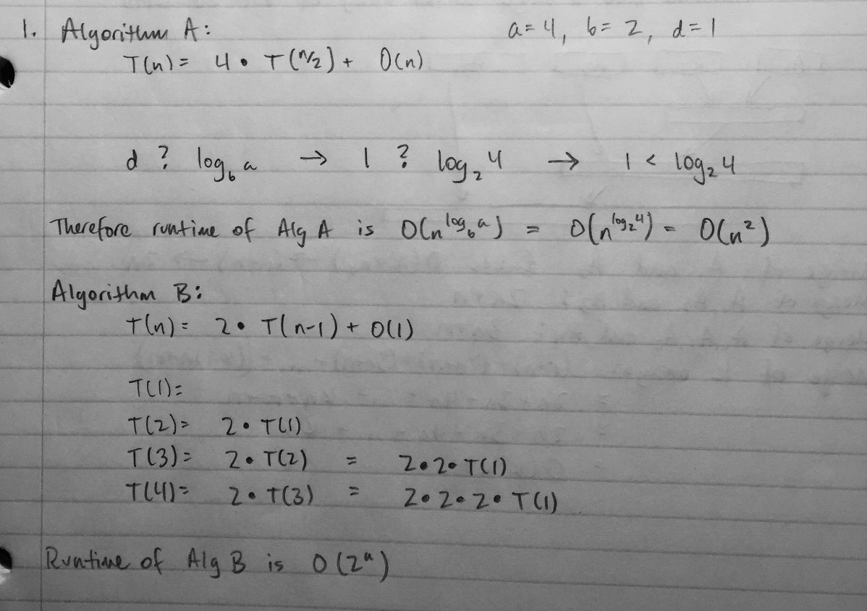  
   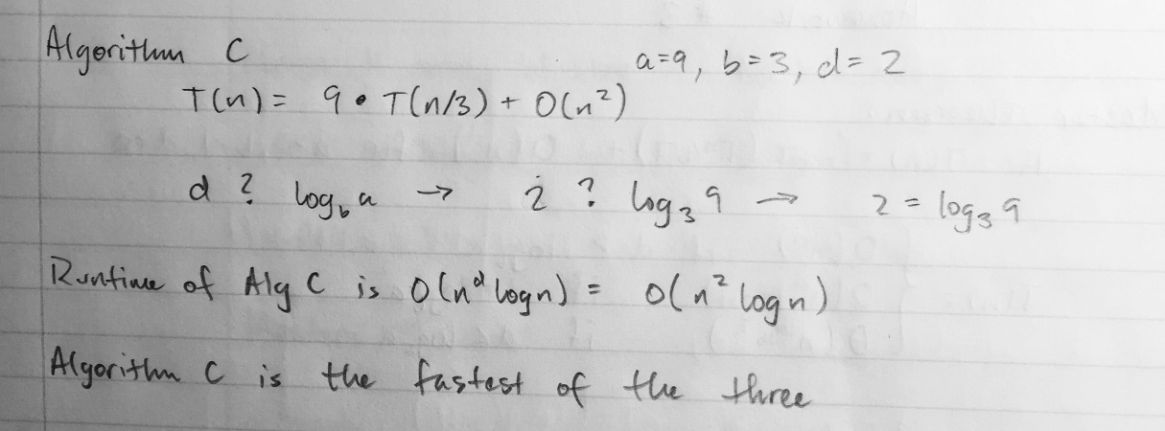
2. 1. Find the minimum and maximum numbers in the array.
   2. Create a new Array A of size M both set at 0.
   3. Scan through the array, and for each element X[i], increment A[min{X[i]} + X[i]].
   4. Create a new array Y[1 … n].
   5. Scan through A[] again, for each element A[i], put A[i] values of I into the next empty slots of Y[].  
      The output of the sorted array is found by scanning through A[i] and outputting the values in order. It takes a constant amount of work to scan through arrays of size n and M so it takes O(n + M) time.
3. 